

**School of Computing**

**SRM IST, Kattankulathur – 603 203**

**Course Code: 18CSC206J**

**Course Name: Software Engineering and Project Management**

| **Experiment No** | 5 |
| --- | --- |
| **Title of Experiment** | Prepare Work breakdown structure, Timeline chart, Risk identification table |
| **Name of the candidate** | VENKAT ADITYA VELLANKI |
| **Team Members** | PARAS PAL, M.V. MANISH |
| **Register Number** | RA2111003011799 |
| **Date of Experiment** | 03-03-2023 |

**Mark Split Up**

| **S.No** | **Description** | **Maximum Mark** | **Mark Obtained** |
| --- | --- | --- | --- |
| 1 | Exercise | 5 |  |
| 2 | Viva | 5 |  |
| **Total** | | **10** |  |

**Staff Signature with date**

**Aim:**

To Prepare Work breakdown structure, Timeline chart and Risk identification table.

**Team Members:**

| **Sl No** | **Register No** | **Name** | **Role** |
| --- | --- | --- | --- |
| **1** | **RA2111003011818** | PARAS PAL | **Rep** |
| **2** | **RA2111003011819** | M.V. MANISH | **Member** |
| **3** | **RA2111003011799** | V. VENKAT ADITYA | **Member** |

**WBS (WORK BREAK DOWN STRUCTURE):**

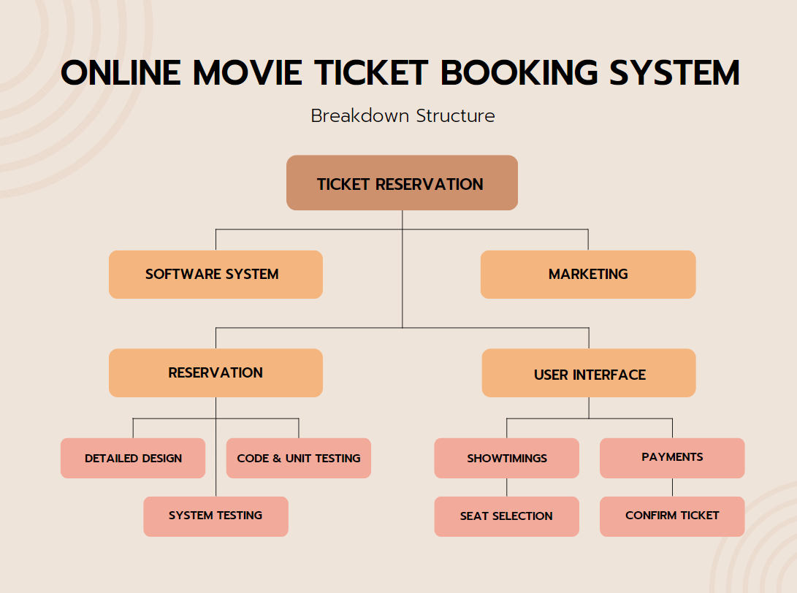

**Online Movie Ticket Booking System**

1. Initial Stage
   1. Planning
   2. Detailed Design
2. Methodology (Functional & Non-Functional)
   1. Marketing
   2. Resources Management
3. Testing
   1. Unit Testing
   2. Security Measurements

**TIMELINE – GANTT CHART:**

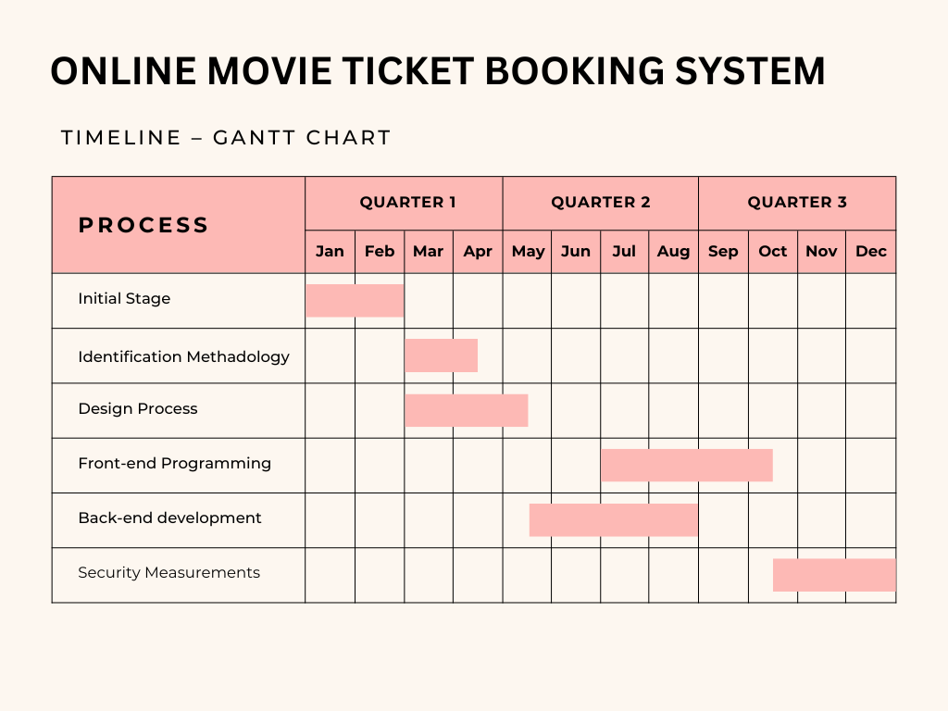

**RISK ANALYSIS – SWOT & RMMM:**

**SWOT: -**

**S - STRENGTHS**

**W - WEAKNESS**

**O - OPPORTUNITIES**

**T - THREATS**

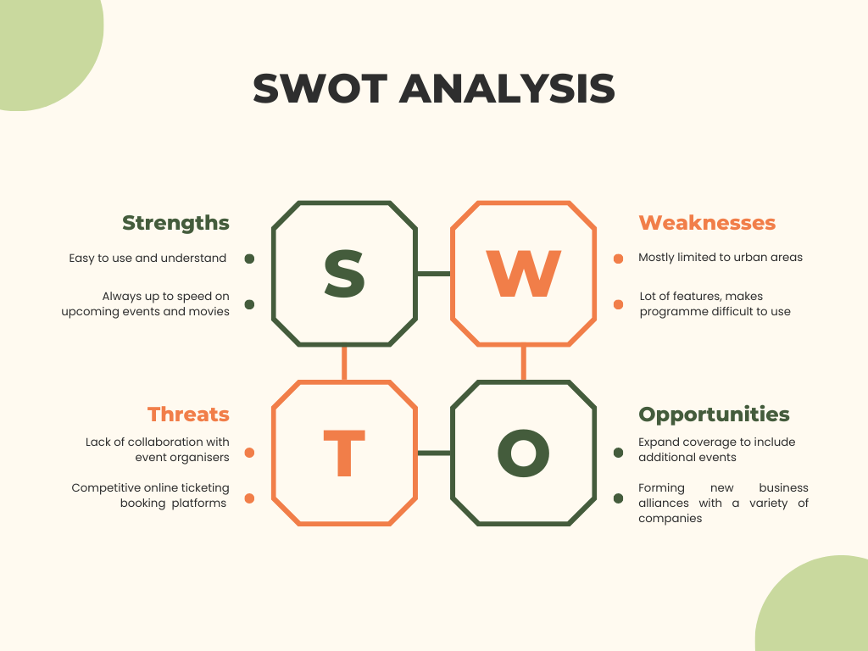

**RISK MANAGEMENT FRAMEWORK:**

| **Response** | **Strategy** | **Examples** |
| --- | --- | --- |
| **Analyze risks** | This will help prioritize the risks that require immediate attention. | * Servers * Malware |
| **Identify risks** | This may include cyber-attacks, data breaches, system failures, human errors, natural disasters, and other potential threats. | * Cyber attacks * Data breaches |
| **Monitor risk** | This may involve regular security assessments, penetration testing, and vulnerability scanning | * Hacking * Firewalls |
| **Train staff** | Regular training and awareness programs should be conducted to keep everyone up- to-date on the latest security threats and trends. | * Protocols * Threats |

Result:

Thus, the work breakdown structure with timeline chart and risk table were formulated successfully.